CUSTOMER JOURNEY MAP :

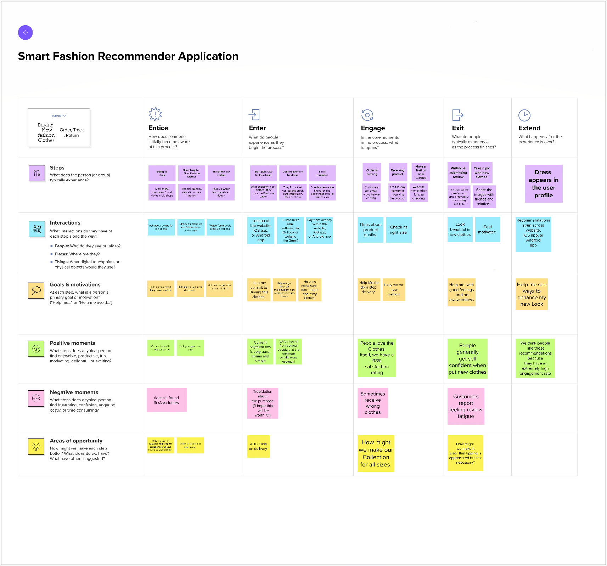

TEAM ID : PNT2022TMID31571

TEAM LEADER - CASSANDRA MARIA MURPHY

TEAM MEMBER - DEEPIKA D

TEAM MEMBER - DHANUSHIYA K

TEAM MEMBER - KEERTHANA P L